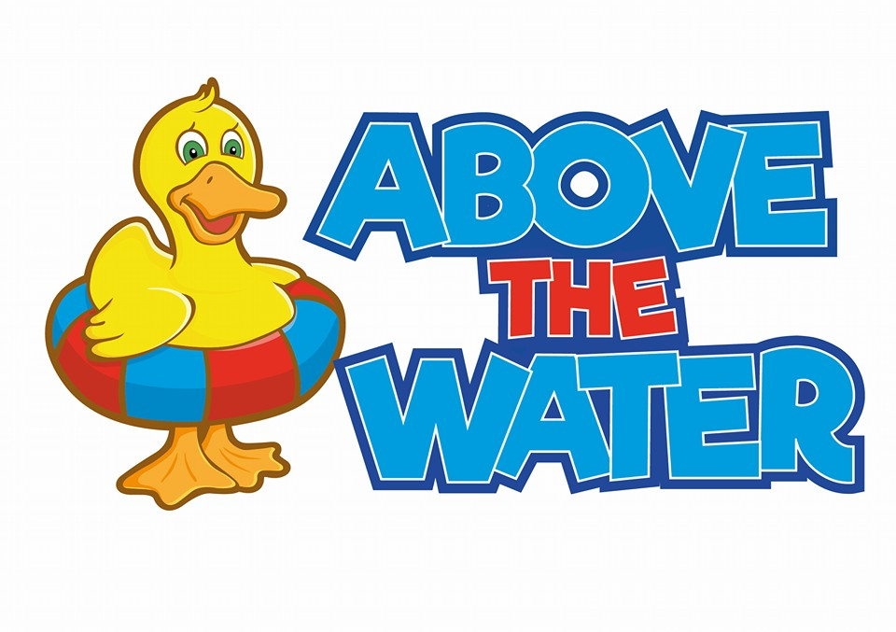

Cancellation and Enrolment policy

Cancellation
We understand that people are ill and cannot make their lesson. Please give us as much notice as possible. We require 24 hours’ notice to ensure you are on our ‘Catch up’ list. This will allow us to offer the space to someone else and/or to inform the swimming teacher. Please do not bring your child swimming if they have any of the following: Conjunctivitis, Ear infection, chicken pox, diarrhoea, impetigo, vomiting, or a very bad cold – if your child is suffering from any of the above they should be cleared by a doctor before attending our classes. Vomiting or diarrhoea should have stopped for at least 48 hours before swimming. This is very important as these can spread and impact all of the pool users. It is also very important to ensure that you do not eat 2-4 hours before the swimming lesson. If you must please eat a very light meal such as healthy snacks that are easy to digest and rich in vitamins and minerals to provide energy.

If a child does not attend a lesson due to cold/flu a refund will not be given unless a doctor’s note is provided. Once confirmation has been sent to you, Above the Water is under no obligation to refund any classes if you wish to terminate your course with us.

With regards to holidays and parties etc we have put ‘catch up lessons’ in place. Please note however that these are not something we will regularly make accessible for you, however, we will try to do our best to avoid you losing out on money. We fit these around our cancelled lessons. This is not always available as we rely on the honestly of our clients to give us as much notice as possible so we can advise you of a space. We do not guarantee ‘Catch up’ lessons but will always try to ensure you have at least one with us.

When the pool must be closed, we will contact all parents/guardians. Please note that this is not always an easy task especially if it is short notice, but we will try to get the message out to as many people as possible. Where possible, we will credit the missed lessons towards the next course of lessons. If a pool should become unusable long-term Above the Water will try to find an alternative pool if you wish to follow us. Should you not wish to take the alternative pool a refund will be given. If Above the Water cancels a lesson due

to a problem with the pool or teacher absence then a full refund for that lesson will be given or an alternative slot given that suits. We are unable to refund any participants due to adverse weather conditions if the pool itself is open. Above the Water will decide whether or not it is safe for our users.
Enrolment
All parents must inform Abaigh if you no longer want to have swimming lessons with us. Please do this as soon as possible. Above the Water gives priority for future terms to all current swimmers before releasing to any new participants. The slot you have booked is therefore yours, unless stated otherwise or a change in lesson.

When enrolling with Above the Water, everyone must fill out a medical form:
https://docs.google.com/forms/d/e/1FAIpQLSfnnEDMKTyXmgs-sj3KAFWZ2YwDMqyQB2SwtvYbDLMViYrTmQ/viewform
Should you or your child have a medical condition please let us know at your earliest convenience – all information will be kept strictly confidential. This is to inform our teaching to ensure we are providing the very best service.

